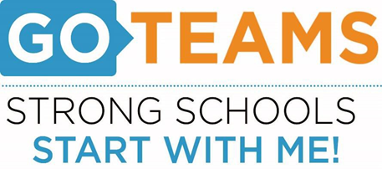

**MEETING NOTICE**

|  |  |  |  |
| --- | --- | --- | --- |
| **School** | **Date** | **Time** | **Location** |
| Atlanta College and Career Academy | September 8, 2021 | 5 p.m. | Virtual |

**Notice Prepared By:** Tasharah Wilson **Date Posted: 8/20/2021**

**Meeting Agenda**

(*agenda may be amended*)

*This meeting will not allow for Public Comment*

1. **Action Items** 
   1. Approval of Agenda
   2. Fill Open Parent Member Seat
   3. Appoint Student Representatives
   4. Approval of Previous Minutes
   5. Election of Officers
      1. Chair
      2. Vice-Chair
      3. Secretary
   6. Review and Approve Public Comment Format
   7. Set GO Team Meeting Calendar
   8. Review, Confirm/Update, and Adopt GO Team Meeting Norms
2. **Information Items** 
   1. Principal’s Report
   2. Information Items
      1. COVID Protocols

**Atlanta College and Career Academy**

**Date: September 8, 2021**

**Time: 5 p.m.**

**Location: Virtual**

1. **Call to Order**
2. **Roll Call; Establish Quorum**
3. **Action Items** 
   1. Approval of Agenda
   2. Fill Open Parent Member Seat
   3. Appoint Student Representatives
   4. Approval of Previous Minutes
   5. Election of Officers
      1. Chair
      2. Vice-Chair
      3. Secretary
   6. Review and Approve Public Comment Format
   7. Set GO Team Meeting Calendar
   8. Review, Confirm/Update, and Adopt GO Team Meeting Norms
4. **Information Items** 
   1. Principal’s Report
   2. Information Items
      1. COVID Protocols
5. **Announcements** 
   1. New GO Team Member Training and Orientation
6. **Adjournment**

Join Zoom Meeting   
<https://atlantapublicschools-us.zoom.us/j/83868523842?pwd=cHZmdWZRVHpMbXdDUFQ1T09uSEhzZz09>

Meeting ID: 838 6852 3842   
Passcode: 830436   
One tap mobile   
+13017158592,,83868523842#,,,,*830436# US (Washington DC)   
+13126266799,,83868523842#,,,,*830436# US (Chicago)

Dial by your location   
        +1 301 715 8592 US (Washington DC)   
        +1 312 626 6799 US (Chicago)   
        +1 929 205 6099 US (New York)   
        +1 253 215 8782 US (Tacoma)   
        +1 346 248 7799 US (Houston)   
        +1 669 900 6833 US (San Jose)   
Meeting ID: 838 6852 3842   
Passcode: 830436   
Find your local number: <https://atlantapublicschools-us.zoom.us/u/kcAhOBBzbA>

Join by Skype for Business   
<https://atlantapublicschools-us.zoom.us/skype/83868523842>